Module 3: Key Support Functions for Insurer Success 1
Lesson 2: Product Development 1
Learning Objectives 1
The Importance of Product Development 2
The Product Development Process and Product Planning 6
Comprehensive Business Analysis 14
Technical Product Design 26
Implementation and Launch 29
Product Monitoring, Evaluation, and Feedback 38

Module 3: Key Support Functions for Insurer Success
Some functions primarily provide support to other functions. In this module, we’ll discuss three of the most important support functions that are essential to an insurance company’s success.
In this module, you’ll learn about
- How insurers use research and data to develop their marketing mix
- The process insurers use to create successful new products
- How the legal and compliance functions work together and separately to keep the insurer on the right side of the law

Lesson 2: Product Development

To survive and thrive, an insurer needs an ever-evolving portfolio of products that’s responsive to the changing environment and to customers’ changing needs. But insurance products are complex, expensive to develop, and subject to a litany of regulations designed to protect customers. Learn about the process insurers go through to create products that will succeed in the marketplace.

Learning Objectives

- Explain the importance of product development to an insurance company's success.
- Describe the overall product development process.
- Explain how insurance companies generate and screen ideas for new products.
- Describe the five elements of a comprehensive business analysis, and identify the responsibilities of an insurer's functional areas in this process.
- Explain the technical product design stage of product development.
- Describe Day 1 and Day 2 functionalities that must be put into place during product implementation.
- Describe how insurers use transaction processing systems, expert systems, and other information systems.
- Describe how insurers monitor, evaluate, and use feedback to improve both their product offerings and their product development process.

The Importance of Product Development
Learning Objective
Explain the importance of product development to an insurance company's success.
Product development is a pretty straightforward concept: it's a company's process for creating new products to sell. A company needs to sell products to stay in business, after all.
But why is product development so complicated for insurers? Why do they work so hard to establish the right process to develop new products? And why do so many companies have teams that do nothing but develop products, and yet even more employees who help with the process?
A flawed product development process has real consequences. A company may take a product to market quickly, but maybe it sells poorly, or something else goes wrong. Sometimes a product can even sell exceptionally well, but cause a loss for the company, thanks to a problem with the financial design.
Developing a new product is risky, so companies carefully weigh the risk versus the reward. The effort must justify the time and expense involved. As you'll see, insurers consider many factors before introducing new products.
Consider the following scenario.
This new product from Gigantic could be great. I like Forthright's products better overall, but they seem slow lately with product development.

Start
Why can't Forthright just push out new products more quickly? There are several reasons. A good product has to satisfy a number of objectives, which may pull the project in different directions.
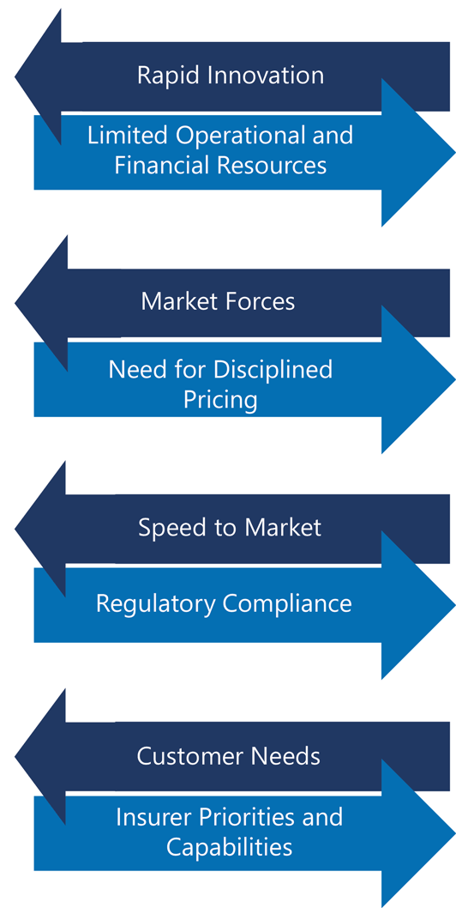
Let's look at some factors that Forthright would consider before introducing a new product.
Characteristics of an Effective Product Development Process

Product development affects revenue. The majority of an insurer's revenues come from product sales. New products are essential to product sales because old products become less and less attractive and eventually become obsolete.
Also, the product development process needs to be efficient. "Speed to market"—how quickly a new product can be developed and offered for sale—is an important factor in the competition with other companies for revenues.
Product development involves many expenses.
- Large numbers of personnel are involved in product development.
- New product ideas must be meticulously researched.
- Systems and processes may need to be re-tooled to handle a new product.
- Compensation for financial professionals is a large cost element.
- Companies must commit reserves and capital to support the new product.
- Many new products continue to be improved after they are introduced to the market.
So, an effective product development process helps the insurer manage the cost of developing new products and also helps ensure that resources are not wasted on unsuccessful products.
Like any commitment of resources, developing a new product is an investment, so it involves risk. One risk is that the new product might not achieve adequate sales volume. Alternatively, the product might sell well, but not earn an adequate profit, or any profit, or it might lose money.
As always, the higher the potential return, the greater the associated risk.
An effective product development process helps the insurer achieve its desired risk profile.

Select each statement that correctly describes why an effective product development process is essential to an insurer's financial success.
- Profitable new products are essential for an insurer’s revenue prospects.
- New products often involve considerable cost to the insurer.
- Releasing a new product is risky.
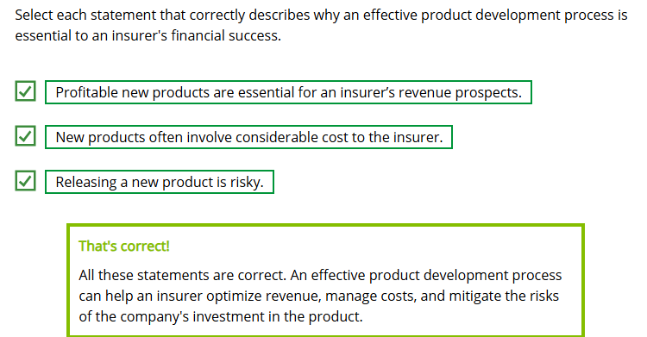

The Product Development Process and Product Planning
Learning Objectives
Describe the overall product development process.
Explain how insurance companies generate and screen ideas for new products.
A Society of Actuaries report found that most insurance companies have a dedicated product development team. Most often, at large and medium-sized insurance companies, product development even has its own department. Source
All product development teams rely on expertise from across the organization, but the number and order of the steps can vary. It's important for a company to implement the steps that best work for that organization. Let's see how these steps in a typical product development process work together to produce the desired results.
Overview of the Product Development Process
Product development goes through a typical process cycle. Starting with generation of new product ideas, the cycle continues through analysis of promising ideas, design of products that are selected from among those promising ideas, through product launch, and then through a feedback and adjustment process which leads back to new ideas.
The product development process at most companies can be broken down into these five steps.
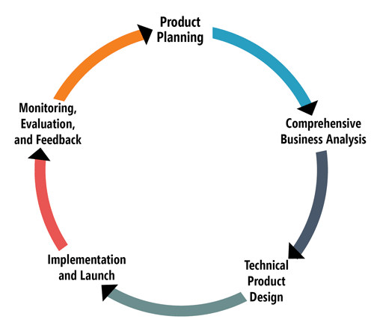
Use the right arrrows below to learn more about each step in the process.

Product Planning
The product development team gathers ideas for product concepts that seem to fill a customer need and does initial screening and testing on those ideas.
Product Planning

Insurers continuously search for ideas for new product concepts that will meet the needs of the company and its target markets. This is the first step in the product development process: product planning.
The first step in product planning is idea generation. For example, insurers monitor which of their own products—and which products offered by competitors—are successful. They also conduct market research.
Developing a "new" product encompasses a range of projects, including a simple rate change to modify an existing product, a product revision, and a full-blown new product. Each of these projects requires new regulatory filings—even modifications to existing products that had already undergone filing.
- Rate change—Changing a fee or charge on an existing product
- Product revision—Any change that lies between a rate change and a new product, such as adding a rider to an existing policy
- New product—Developing a significant new product feature or function and a unique product identifier
Sources of New Product Ideas
You might ask why we would develop a completely new product if we already have a product we can modify. Wouldn't modifying an existing product be cheaper and quicker?
Customer needs can change as the environment changes. We need to do whatever we can, within reason, to make sure our products meet those needs. We get a lot of new product ideas from changes to the law, new regulations, and changes to the tax code. We can even get ideas from watching what our competitors are doing—and whether or not it's working for them.

Generating Ideas
The actual process of generating ideas involves people from throughout the company, not just the team that will eventually design the project.
- Research teams investigate the market's shifting needs and competitors' products.
- Actuaries may discover an opportunity in the course of assessing probabilities.
- The sales department and top financial professionals give feedback on what customers want or don't want.
- Marketing teams propose ideas that emphasize the strengths that the company is known for.

Ideas for new products or enhancements and modifications to existing products can come from a variety of sources. Of the following possible sources of new product ideas, which four sources do you think provide companies with the most new product ideas?
- Customers
- Financial professionals
- Product development team
- Actuaries
- Marketing research
- Marketing intelligence / Competitors' products
- Policy services department
- Agency / Sales department
- Consultants
- Marketing specialists
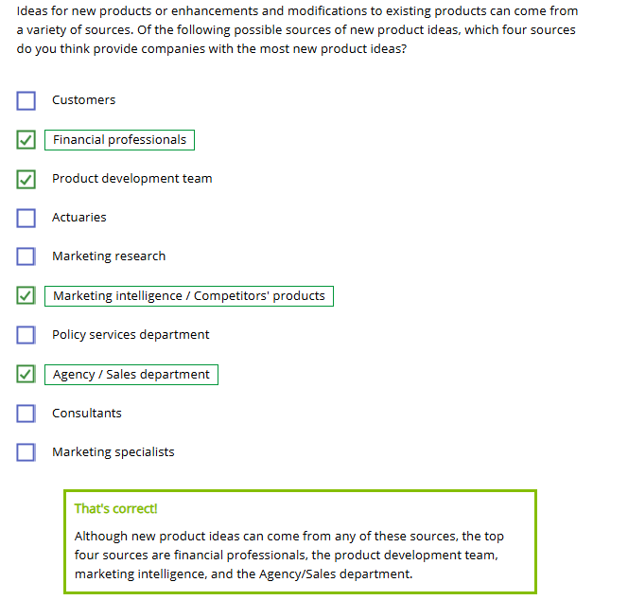
Idea Screening
Once a pool of new product ideas is generated, each idea must be screened to identify which ones to study further.
Of course, idea screening helps the product development team to select promising ideas, but it also helps to conserve resources by eliminating ideas with poor potential.

Select each factor that Forthright would use to screen ideas. Choose all that apply.
- Marketability to target markets
- Compatibility with the company’s goals and market position
- Potential profitability
- Desirability and understandability to target customers
- Compatibility with the company’s distribution channels
- Compatibility with the company’s information systems
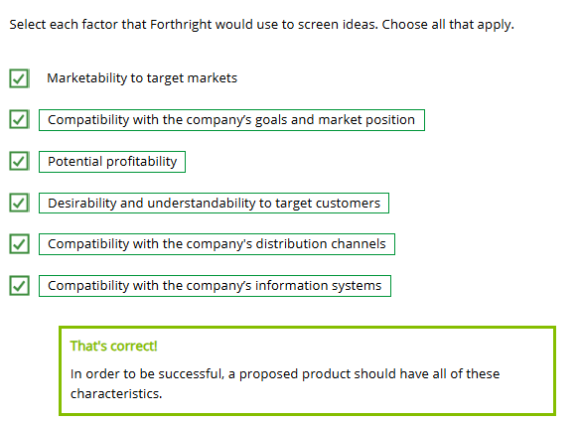
Concept Testing
Some companies screen ideas through concept testing, which consists of describing product ideas to financial professionals or potential purchasers and seeing which ideas have the greatest appeal.
Some companies test product concepts using
- Focus groups—small group interviews in which participants discuss their opinions
- Large-scale quantitative research studies, which use structured data-collection methods and carefully defined samples

True or False?
A change in a fee or charge on an existing product qualifies as a "new" product.
- True
- False
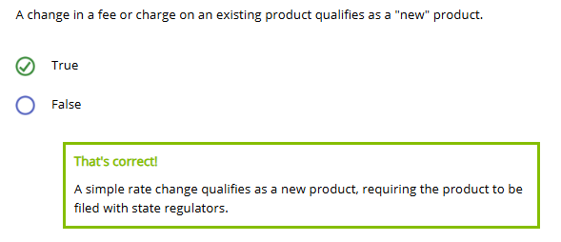
Marketing research is the primary source for new insurance product ideas.
- True
- False
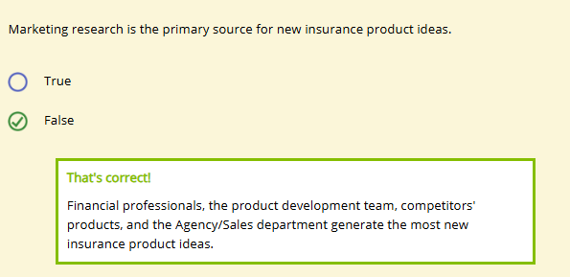
Concept testing using __________ involves a formal collection of structured data from large, carefully defined samples.
- Quantitative research
- Focus groups
- Idea screening

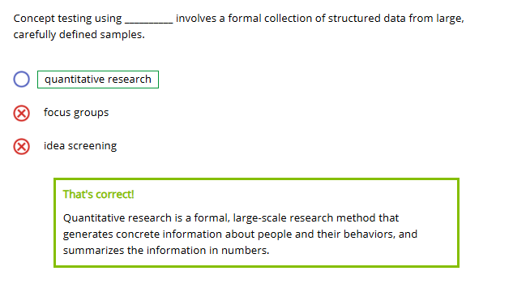

Comprehensive Business Analysis
Learning Objective
Describe the five elements of a comprehensive business analysis and identify the responsibilities of an insurer's functional areas in this process.
Each product idea that survives the initial screening process undergoes a comprehensive business analysis to determine the product's feasibility and marketability.
Comprehensive business analysis
- Creates a foundation for the later stage of technical product design
- Builds a case for company decision makers that the proposed product is worth developing
Elements of Comprehensive Business Analysis
Click or touch each heading below for information about comprehensive business analysis.
Market Analysis
A market analysis is an evaluation of all factors that might affect product sales. The market analysis attempts to demonstrate that market demand exists to support a proposed product.
Product Design Objectives
Product design objectives are the product's basic characteristics, benefits, fees and charges, any limitations on issuing policies, and operational and administrative requirements such as underwriting guidelines. These objectives guide technical product design later.
Feasibility Study
A feasibility study evaluates the operational and technical viability of producing the product and the impact of the new product on the company's existing products.
Marketing Plan
As described in the previous lesson, a marketing plan provides a detailed description of the marketing goals for a product or product line, and describes the strategies and the implementation and control efforts the company intends to use to achieve those goals.
Marketing Projection
A marketing projection is an estimate of future sales, including sales volume (number of units sold), sales revenue (dollar volume of sales), expenses, and profits. Early estimates are rough but become more refined as the process progresses.
Product Proposal
A product proposal is a document presented to the appropriate executives—for example, the risk committee—for a go/no go decision on the idea. It gathers and condenses information from the previous documents.
The product proposal contains enough information for the senior executives to make an informed decision about whether to go ahead with the project. When working on the remaining steps in the product development process, teams use the product proposal as a guide. A product proposal describes the following aspects of a product:
- The product's purpose
- Key product features
- The target market for the product and projected sales volume
- Differentiation from other products
- Plans for promotion, advertising, distribution, and sales
- Requirements for administrative resources, including technology
- Probability projections and capital needs such as investment changes
- Regulatory considerations

Here are just a few of the tasks that need to be completed during comprehensive business analysis. Read each task and determine what area would be responsible for that task.
Reviews the proposed product to ensure that it complies with all legal and regulatory requirements
Assesses whether the company's current systems can accommodate the new product
Comprehensive Business Analysis Responsibilities
As we said, those were just a few of the tasks to be completed. Here is a more complete list.
Marketing

- Conducts a market analysis to determine whether customers want the new product
- Prepares a marketing plan and marketing projections
- Gathers and analyzes information about potential target markets and competitors' products
- Evaluates how the new product might affect in-force business and sales of the insurer's current products
- Determines the most appropriate distribution channels and advertising and sales strategies
- Works with the compliance area to determine the best test markets in terms of legal requirements and prohibitions
Agency Operations

- Determines if changes are necessary for the current sales force to sell the new product effectively
- Helps determine the proper training materials for financial professionals
- Must be very responsive to the communications that the marketing department sends out for both test phase and ultimate launch
Actuarial

- Develops product design objectives with advice from other functional areas, including marketing, underwriting, and compliance
- Performs preliminary calculations to determine if the new product can be priced to be competitive and profitable within a reasonable time frame
Underwriting

- With advice from actuarial, establishes initial underwriting guidelines
Investments

- With advice from actuarial, determines what types of investments are needed to support the expected payment of benefits under the new product and also to add to the company's profits
Claim Administration

- Examines claim assumptions made by actuarial staff in product design
- Determines whether current claim systems and staff can adequately administer new product
Customer Service

- Considers whether current staff and procedures are adequate to support new product
- Estimates any additional staffing costs for new product
Information Technology

- Assesses whether the current information systems can support the new product
- Estimates any costs necessary to upgrade or outsource systems
Accounting

- Reviews financial reporting requirements that the insurer must meet in developing and selling the new product
- Evaluates how the new business will be reflected in the company's financial statements
Legal/Compliance

- Assists in developing the product design objectives
- Reviews the product to ensure that it complies with all legal and regulatory requirements in the jurisdictions in which it will be sold
- Determines policy filing requirements and whether the product will be prohibited in any jurisdictions
- Advises marketing during the development of product advertisements

Technical Product Design
Learning Objective
Explain the technical product design stage of product development.
After the risk committee or other executive group approves a proposal for a new insurance product, the product development team moves on to technical product design.
In this stage, the product development team uses the more general product proposal as the basis for a highly detailed product design. Two primary elements included in the technical product design are the product's financial structure and the contract forms for the product.
The technical product design phase typically involves a three-part process:
- Establishing a financial design
- Testing a financial design
- Budgeting and scheduling
Establishing a Financial Design
The process of establishing a financial design is extremely technical. Actuaries—highly trained experts in the mathematics of insurance—create the financial design of a new insurance or annuity product by answering questions involving the product's
- Premium rates
- Account or transaction fees and charges
- Surrender charge schedules
- Cash value growth schedules or formulas
- Underwriting standards, tables, and risk classes
- Reinsurance strategy and retention limit

The goals of financial design are
- Ensuring that the company will be able to cover future benefits and expenses, even in crisis conditions
- Creating a package of benefits and costs that will have marketplace appeal for purchasers and financial professionals
- Providing an adequate return to the company’s owners
Testing a Financial Design
How do actuaries test proposed financial designs? Primarily by using financial models: computer programs that describe the product mathematically. A model shows how the financial values below interact over a long future period.
Financial models show
- Cash inflows: premiums, deposits, charges, fees, investment income, etc.
- Cash outflows: benefits, surrenders, expenses, etc.
- Profitability
Models also "stress test" the product's financial design, which means testing product performance in extremely unfavorable conditions.

Select each negative condition that can impact an insurance or annuity product.
Budgeting and Scheduling
Once the technical design team has figured out the what of the product design, it's time to figure out the how and when.
The budgeting portion of this phase involves preparing a budget for the human, financial, and computer resources needed to implement the product.
The scheduling portion of this phase traditionally involves developing a project schedule. However, an insurer may use forms of project management, such as agile product methodology, that do not follow a fixed schedule in great detail.
In general, the goals of project scheduling are to identify which tasks need to be completed sequentially and which may be completed concurrently, and to assign team members to tasks accordingly.
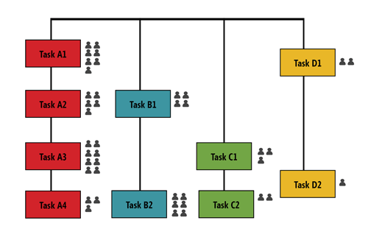

Implementation and Launch
Learning Objectives
Describe Day 1 and Day 2 functionalities that must be put into place during product implementation.
Describe how insurers use transaction processing systems, expert systems, and other information systems.
Once you have a product, you still need to get it to the customer. Introducing the product—or placing it on the market—requires a lot of care. You have to make the internal changes necessary to support it properly.
Most insurers divide product introduction into two parts.
- One part involves product implementation, which includes putting all the necessary administrative structures and processes in place.
- Another part is the product launch, when the company finally makes the product available to customers.

"We start some product implementation tasks while the technical product design stage is still in progress. We want to make sure the support structure is already in place when the product is ready to go to market."
Day 1 and Day 2 Functionality
Insurers want to get the product into customers' hands as soon as possible. After all, time is money! Insurers can speed up the implementation process by determining the new product's
- Day 1 functionality—the "gotta haves"; the elements a company needs to have in place and functioning when the first contract is sold
- Day 2 functionality—the elements that can be delayed until after Day 1
Introducing the product in states where product approval was delayed
We can talk about which activities would take place on Day 1 or 2 for "most companies," but each company must decide for itself which activities to delay until Day 2.
The more activities the company delays until Day 2…
...the more quickly the company can get the product to market
BUT
...the more risk the company takes that something will go wrong.
First, we'll take a closer look at several critical activities that must be completed by Day 1.
Policy Filing
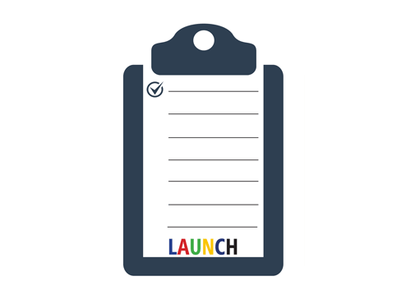
U.S. regulations require insurers to file new product contract forms and any other legally required documents with regulatory agencies in each state in which the insurer will be offering the products. This process is called policy filing.
During policy filing, state insurance regulators review the contract form. Among other things, they check that it includes all the necessary information identifying the insurer offering the product. They make sure it includes all the policy provisions required in that state and that it does not include any provisions prohibited in that state.
They also ensure that the policy satisfies current readability requirements. These requirements ensure that the policy can be understood by people who are not legal experts, and are concerned with sentence length, word length, and the amount of technical and legal language included in the contract.
SEC Registration
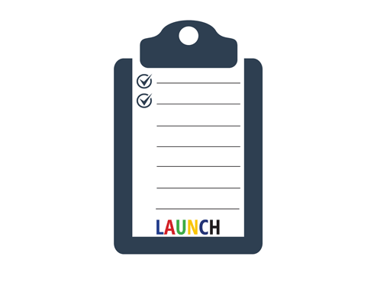
U.S. insurers also need to file a registration statement for variable products with the Securities and Exchange Commission (SEC).
Although the issuer must register a security with the SEC, the SEC does not approve the product or judge its merit.
Disclosure Documents
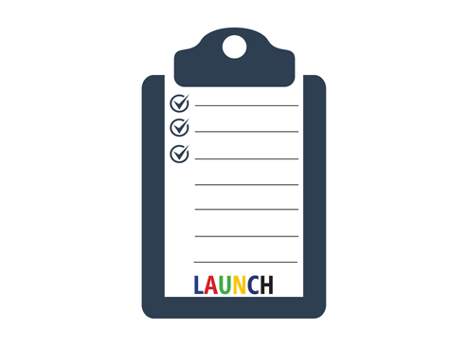
Disclosure is another essential Day 1 requirement. Insurers are required to provide customers with several disclosure documents. In the U.S., insurers need to disclose their policies and procedures for gathering, storing, using, and sharing personally identifiable financial and health information
One disclosure document is intended for customers: the buyer's guide. An insurer must provide a buyer's guide provided to all potential insurance purchasers. The buyer's guide has general information about life insurance and the different types and costs of insurance.
Another disclosure document that must be provided to all potential insurance purchasers contains specific information about an insurance product the customer is considering. This product-specific document is called a policy summary
A third disclosure document, which the insurer must provide to potential variable insurance and variable annuity purchasers, is the prospectus. The prospectus contains specific information about a security being offered for sale.
Information Systems
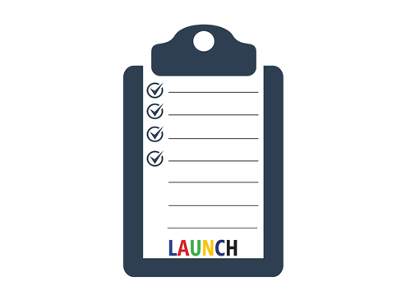
Bringing necessary systems on line is a critical Day 1 activity. The IT staff frequently needs to make changes to the company's existing systems to support the new product. Sometimes, they have to develop or purchase new systems.
With the systems changes, the operational areas frequently must modify the processes and procedures that employees follow. These process changes have to be identified and documented, so the operational staff can be trained properly.
It can take months to get everything done, so systems activities need to be started as early as possible in the development schedule.
Example of Potential Systems Changes
If a new product includes five riders, and all the insurer's other products have only three available riders, then the policy administration system needs to be modified to accept additional riders. The insurer's website and other systems may also need changes.
As the example implies, the introduction of a new product almost certainly necessitates changes to the insurer's admin system. A policy administration system—often simply referred to as the admin system—is used to record information about the insurer's customers and the products they own and to record transactions related to those products. An admin system is an example of a transaction processing system, which performs high-volume, routine, and repetitive business transactions, including
- Application processing
- Policy issue and administration
- Premium billing
- Claim administration
- Salary and commission payment
An insurer may use multiple admin systems, each supporting a different area (underwriting, claims) or a different type of product. Insurers sometimes use admin systems purchased from one of the several IT vendors who service the industry or they might develop their own systems internally.
In addition to the admin system, here are other common types of systems that may need to be updated to reflect a new product.
Common Systems for Day-to-Day Tasks
Click or touch in the boxes below to learn more.

Document Management Systems
Document management systems store, organize, and retrieve documents that have been (1) created electronically and converted to digital images by computer or (2) created on paper and converted to digital images through imaging, or scanning.

Workflow Management Systems
Workflow management systems automatically route work items, such as documents, to staff members for processing, placing the items in a work queue so that the jobs are available when staff members are ready to work on them.

Common Systems to Aid Decision Making
Click or touch in the boxes below to learn more.

Business Intelligence Systems
A business intelligence system analyzes data and information captured and processed by transaction processing systems and produces reports to help management and employees evaluate business situations, make decisions, and solve problems.
One form of business intelligence is business analytics, which includes a variety of technologies, applications, and processes as well as statistical and quantitative analysis. Business analytics provide detailed information such as product sales patterns to help management make decisions or solve problems.

Expert Systems
An expert system stores knowledge in the form of rules and applies those rules to make inferences and decisions similar to the way a human expert does. Business intelligence helps people make decisions, but expert systems suggest decisions themselves. Expert systems can be used for
- Life insurance underwriting
- Claim administration
- Detection of claim fraud

Training for Employees and Financial Professionals
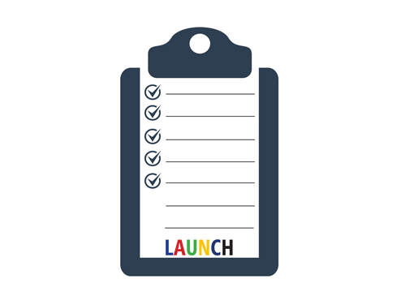
Another critical activity in new product implementation is training.
Working with the training area, the product development team makes sure that employees and financial professionals receive the training they need to sell and administer the new product. They also create the training materials that are needed.
Employees and sales staff need to know about the product's features and the legal and regulatory requirements that affect the product.
- Issue instructions show the requirements various functional areas need to follow when selling or administering the product
- Training sessions instruct home office employees on product features, new administrative procedures, and new information management systems and processes
- Training seminars and classes show financial professionals how to sell the product
Promotional Materials
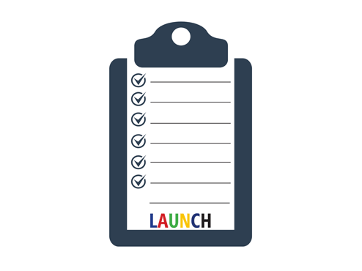
Last but not least in product implementation: promotion and sales support materials. The insurer
- Plans, creates, and arranges to run its promotional campaign
- Designs, creates, and distributes materials for sales and support staff to use in selling the product, including product information, sample sales presentations, and introductory sales kits
The legal department reviews all advertisements and sales support materials. Most states also require insurers to file these materials with the appropriate regulatory body.
Product Launch
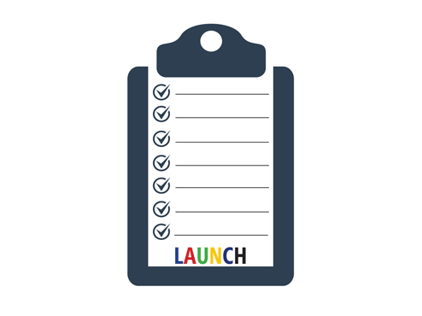
Finally, when the insurer has completed at least the Day 1 implementation activities, the product is ready to launch. In addition to actually making the product available for sale, product launch involves "going live" with all the preparations that were made during product implementation.
Examples:
- IT and business process changes are put into operation
- Advertising and sales support materials are distributed
- Press releases and promotional materials are sent to media contacts
But who do you think the insurer most wants to get excited about the product?
That's right: financial professionals. The insurer works hard to catch financial professionals' attention, teach them about the new product, and generate enthusiasm in order to encourage them to recommend the product to their clients.

Product Monitoring, Evaluation, and Feedback
Learning Objective
Describe how insurers monitor, evaluate, and use feedback to improve both their product offerings and their product development process.
Even if a product is "Day 1 complete" and "Day 2 complete," that doesn't mean the product development team's job is complete.
After introducing a new product, the company needs to monitor whether it performs as expected, and if not, why not.
Remember the control cycle we talk about numerous times in this course? It applies to product performance, too.
Product Evaluation
Here are a number of performance indicators insurers are likely to evaluate. Click or touch each heading below to learn more.
Financial Performance
Insurers evaluate a product's financial performance, including
- The value of contracts sold
- Product profitability
- Mortality and morbidity rates

Performance of Distributors
Insurers also evaluate the performance of distributors, including
- Number of contracts sold
- Number of new customers
- Sales through various distribution channels
- Persistency

Marketplace Reaction
Insurers evaluate the marketplace reaction of customers and competitors, including
- Demographics of purchasers
- Surrender or withdrawal rates
- Whether the new product augments or replaces existing products

Can we do anything about a product's poor performance? Or do we just have to treat it as a learning experience and try harder next time?

Start
The approach we use to save a product depends on what we think the problem is. Use the right arrows below to learn more.

If we think the product is the problem, we can redesign the product's features or revise the product's pricing guidelines.
If a product can't be fixed—that is, if its failure stems from factors outside our control—we may need to eliminate it.
Poor initial sales results don't always mean trouble. New product sales usually grow slowly because (1) customers need time to become familiar with the product; and (2) financial professionals need time to understand the product and feel comfortable selling it, especially if it's different or more complex than the insurer's other products.
When a product is taken off the market, the policies already sold can remain in force for a long time. And unless we sell those policies to another insurer, we're obligated to provide service and benefits to those customers.
Product Development Process Evaluation
The control cycle can be used for another purpose:
To identify strengths and weaknesses of the product development process.
Knowing what works—and what doesn't—helps:
- Improve the success rate of future product development projects;
- Reduce product development costs;
- Improve new product performance; and
- Shorten the time needed to bring new products to market.

